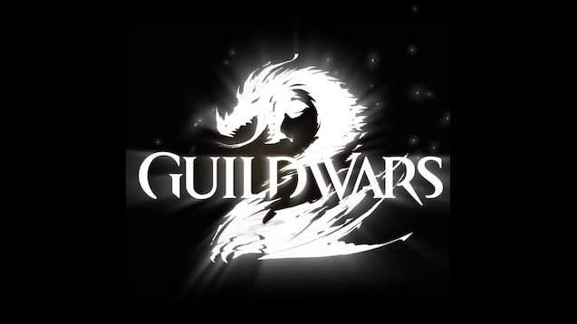

GUILDWARS 2 Serpent’s Ire Guide

Things you need to know about the Serpent’s Ire Meta in the Domain of Vabbi.

By Minerva Frostleaf AKA Kenar Solmen

guardian of the united[gotu] & Exodus/z of the elder dragons/z[GODS]   EU based

First phase: Lure, find and kill Branded Forgotten Zealots

Kill Veteran or Elite branded monsters to lure out the Branded Forgotten Zealots.

* 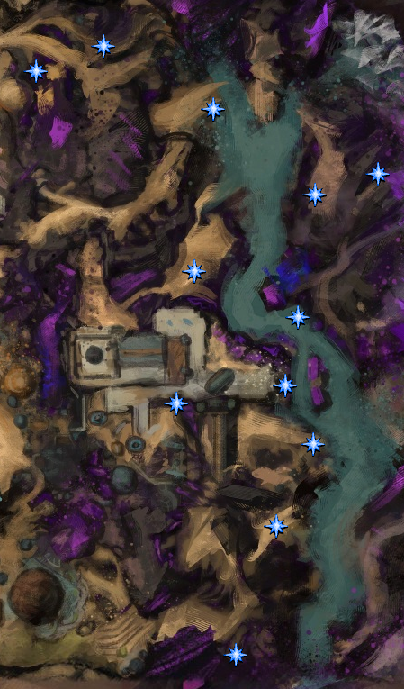Time limit: 30 minutes
* Each time a Branded Forgotten Zealot appears, a warning is shown on the screen & map. It will remain for 8 minutes before it flees again.
* A zealot can spawn on any of the locations shown on the map.
* Mark the 8 locations furthest away from the Markets Ruin Waypoint (4 up and 4 down). The other points players will pass anyway while searching.

This will make searching easier for your squad

* It may be quicker to let a few people hit veterans while those walking with commander kill the spawned zealots.

But don’t attempt this without a half full squad as the squad might trigger multiple at once and your 8 minute time limit will expire.

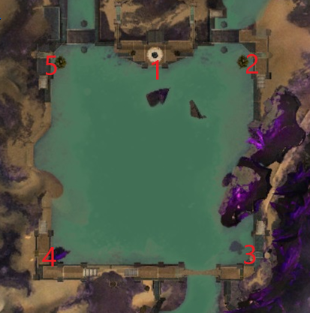Second phase: Save the crystal and kill the Zealots (again)

After the first phase is complete you have 3 minutes to gather everyone at the Ruins of the Mirror of Lyss.

The 5 zealots will reappear and try to shatter the crystal. If it breaks the Meta fails!

* Time limit: as long as the crystal health bar lasts (shown on the side of the screen).
* Each Branded Zealots blue bar needs to be brought down with cc to allow them to be damaged. The blue bar restores in about 10 seconds. At minimum two groups are needed:
* 2 teams with both cc and dps each different zealots continuously to slow the damage on the crystal. 1 team clockwise and the other counter clockwise.
* Preferably there are more teams to slow the other zealots but that depends on the squad size. With about 30 players keep it on 2 teams.
* As long as the cc bar is down it also prevents the Forgotten from damaging the crystal.

Third phase: Boss fight against Ysshi Hessani and Pek Rakt Grag (A Forgotten and a Hydra).

This is basically a straight up boss fight in the middle in front of the Ruin of the Mirror of Lyss

* Time limit: 20 minutes
* Focus on Ysshi Hessani first as he will resurrect Pek Rakt Grag (Hydra) with 50% of its health when it goes down. Note that isolating it and leaving the health intact of Pek doesn’t help as Ysshi will drain 50% of the health of Pek if he is above 90% to heal itself back up by 25%. If he dies once it isn’t a problem but you want the squad to focus on Ysshi.
* At 25% of its health Ysshi will become invulnerable and sparks will appear at the back of the water from the direction of Market ruins waypoint. They will try to reach Ysshi, kill them before they reach him and mount up after the two waves are killed to avoid damage from a massive AoE attack used by Ysshi.
* At 10% of Ysshi its HP you will likely get a second cycle of the sparks. Same approach as before.
* After this you can finish off Ysshi and after that Pek Rakt Grag.

A few things in general to keep in mind during the meta:

1. The CC required is quite high so ensuring that a reasonable amount is present in the group helps. Besides this the portable waystations from Drizzlewood can help a lot. Especially when the squad isn’t full.
2. Reorganizing the group in between the phases is a bit complicated so having at least 2 groups setup beforehand helps. Or mark someone for group 2 and tell him to go counter clockwise or clockwise (depends on what you do) half of squad have to accompany this guy and other half you
3. It is a meta which currently isn’t run often so it took at least 30-40 minutes to get a group which is big enough to deal with all 3 phases. A full squad can probably run everything in about 30-40 minutes. For now it takes about 1 hour total with around 35 members in the squad.